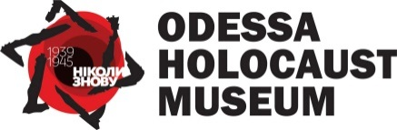

The Second International Conference “Holocaust and International Law” will be held in Odesa, Ukraine on October 24-25, 2019. The Conference is jointly organized by the Ukrainian Association of International Law, the Odessa Holocaust Museum, and the Fund for Fundamental Research Support.
The major objective of the Conference is to intensify the public debate on preventing the crime of genocide, fighting against hate propaganda, xenophobia and intolerance as well as on the need for comprehensive protection of human rights. The Conference will address, inter alia, historical lessons of Holocaust, ways to counteract to the Holocaust denial attempts, the scope of international legal obligations of states to prevent and punish the crime of genocide, as well as the efficacy of the measures currently taken to prevent genocide and to protect historical memory.
The proceedings of the previous (the first) Conference, held in September 2018, can be found in the attachment.
The working language of the conference is English. The application for the conference must be sent to ihl@fsfr.org by September 15, 2019. Applicants should expect notification of the committee decision by 30 September 2019.

